Sr. Business/ Quality Analyst Mar 2005 - Oct 2007
Deutsche Bank, New York, NY
This project involved Portfolio Performance Attribution System designed to help portfolio manager. The application was developed specifically to support Asset Management Group to provide most valuable advisory services to clients on Asset Projections, Mutual Funds, Portfolio Rebalancing, Investment Holdings, Liquidity needs, and future goals. The systems solutions advise the clients on wealth management strategies, provide clear and complete picture of the clients assets in position and those that are held by other providers, full brokerage capabilities, access to IPO's and other 3rd party products, research data and tax and insurance information

- Spearheaded a new QA department and developed processes with quantifiable metrics, increasing efficiency in communicating testing progress and plans to the project team
- Hired and trained QA team members and managed the team’s execution of quality planning and testing
- Experience assessing testing processes, creating, implementing testing strategies and WQA strategies using Agile-testing methodology in UAT phase
- Created reports on Fixed Income on Principal payouts and interest, fixed income portfolio and holdings, Fixed income distribution and cash management, payments, interest accruals and data display.
- Prepared documentation on Data Strategy based on the organization's standard fixed income reporting policy
- Extensive market data analysis on Trade web and Calypso to derive the broker rate
- Worked on functionality, integration, UAT and GUI testing for web application
- Interacted with Business Analyst and Developers for bug reviews and participated in the QA meeting
- Coordinated in creation and execution of QA and testing processes, test strategies and plans, bug documentation and bug tracking and used Requirement management and bug tracking testing tools like Quality Center and Clear Quest.
- Documented the bugs found during testing and worked closely with the developers to resolve them
- Performed the regression tests and verified the bug fixes
- Validated the XML files for Telemarketer team, submitted the batch orders through JMS client and validated the orders in Sling Shot as well as at back end
- Executed SQL queries to verify the data quality and integrity
- Worked with the production team for customer support and solved the customer cases
- Worked on Oracle Application 11i to generate the reports using concurrent manager
- Developed and standardized the test case, defect reporting, and testing summary communication templates, streamlining the daily operations and communications with the project team members
- Developed the internal defect tracking user guide for JIRA defect tracking tool

ENVIRONMENT:
MS Visio, MS Projects, AJAX/Java Script, Oracle 9i, CVS, HTML, XML, Rational Rose, RSS feed Integration, PHP

Read up on what an investment banking analysis application (Portfolio Management Application) looks like here: http://www.iassoftware.com
Tell me about this project?

Well, I was working for the DEUTSCHE BANK Global Wealth Management & Business Banking group of DEUTSCHE BANK. The application I was working on was called “DEUTSCHE BANK Research”. The main users of the application I was the BA for was the investment bankers looking to analyze the stock portfolios in their funds. These bankers were catering to both individual as well as corporate clients. As assets under the company’s management increased, the amount of data to be analyzed and correlated exceeded the portfolio manager’s ability to perform efficiently. The client needed an integrated technology-driven approach to conduct portfolio analysis and to select stocks. The project involved developing a portfolio management system that provided access to comprehensive information for examining and modeling stocks and precious metals.

What was your role on this project? (BA)

As a BA, I was involved from the inception phase in talking to the business team about their requirements for the Portfolio Management System (PMS). Before jumping into the requirements gathering phase, I was given the task of researching existing PMSs out there. I evaluated a company called IAS (Interactive Advisory Software). They have a software called Solution 360 degrees. Evaluation of this software gave us many ideas about how to design and present our own system.

I was involved in wire-framing of the main pages of the system being built. I did these wire frames using Macromedia Dreamweaver. One of the features I am particularly proud about is proposing showing the list of the investment banker’s most valued clients at the time of login for each financial analyst. This requirement came about as a result of DEUTSCHE BANK’s focus on customer service and Customer Satisfaction. When a Financial Analyst sees on a daily basis, their richest clients, they are expected to call them and make sure their needs are being met.

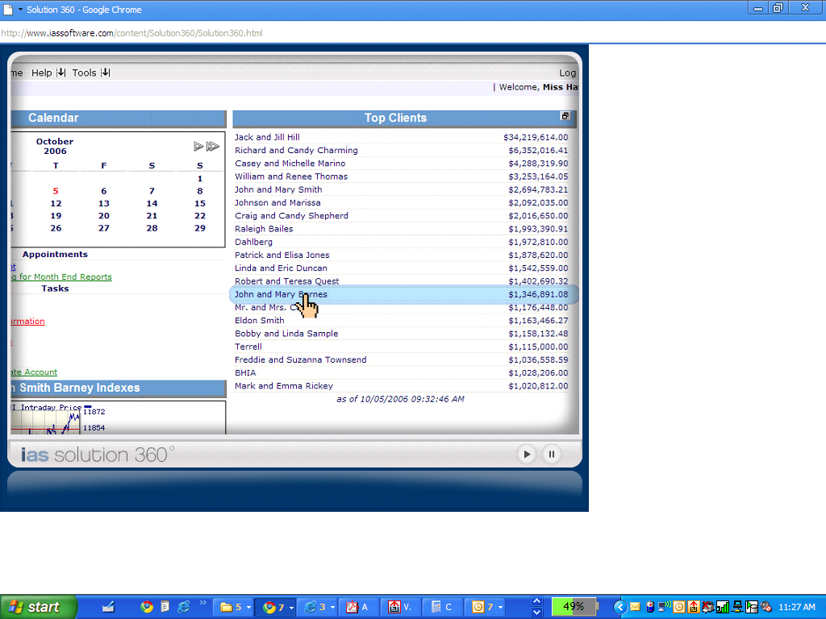

Another aspect of the application I was involved in was the client interview application. This application let a financial analyst interview a prospective client to understand their investment goals (risk, return, money liquid or not, etc.). If someone asks, how come this feature is being added now in 2007, you can say that DEUTSCHE BANK was using a separate application (Excel) to take all this information from the end client. However, this project aimed at integrating the client interview application with the main PMS.

There were a lot of financial modeling tools available in this application. E.g., financial analysts can tell a client what mix of stocks, bonds, cash and annuities to put their funds in.

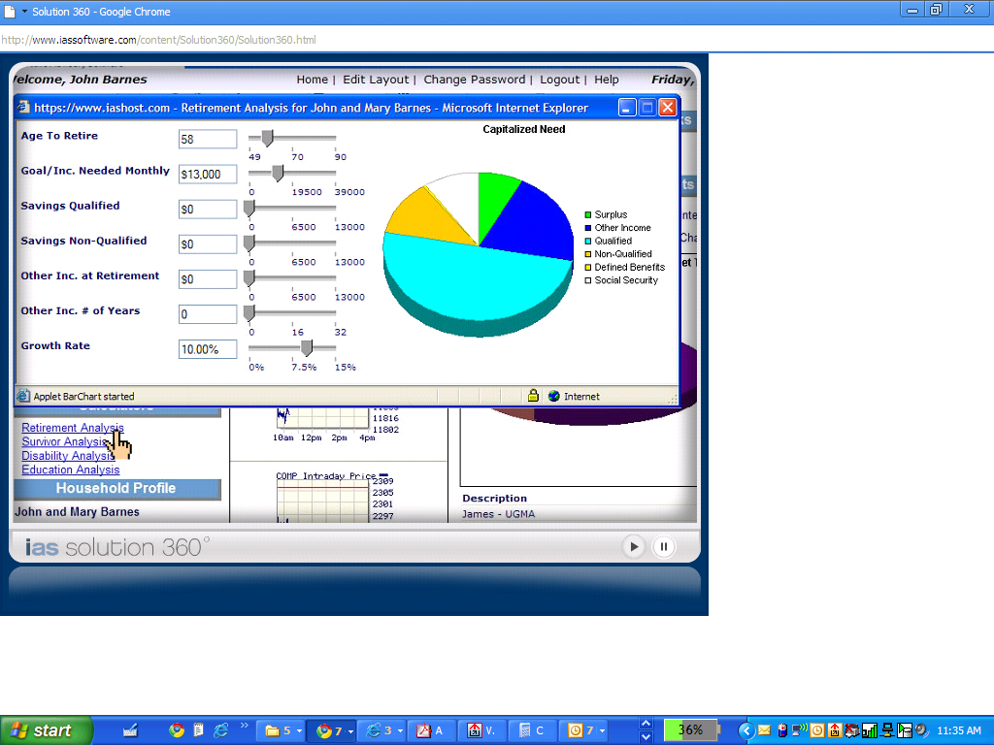

Location:
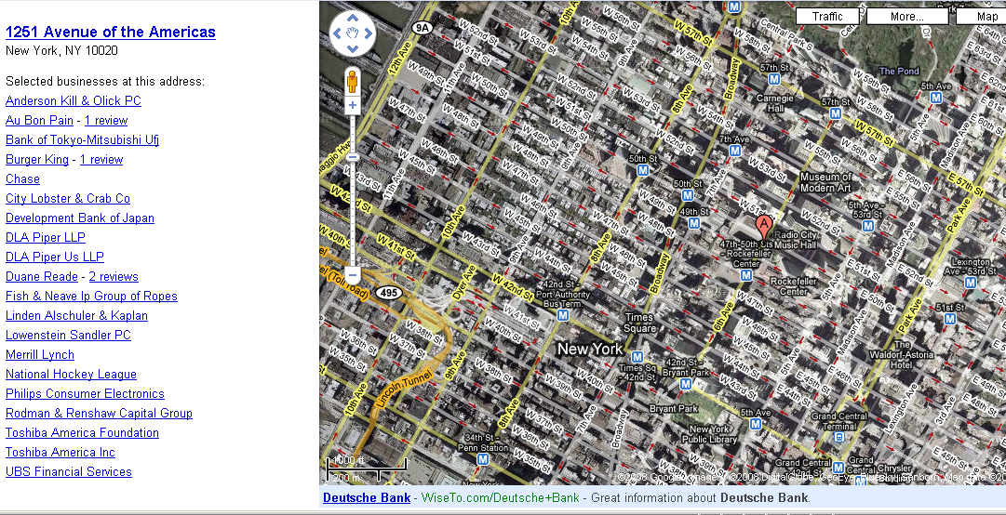

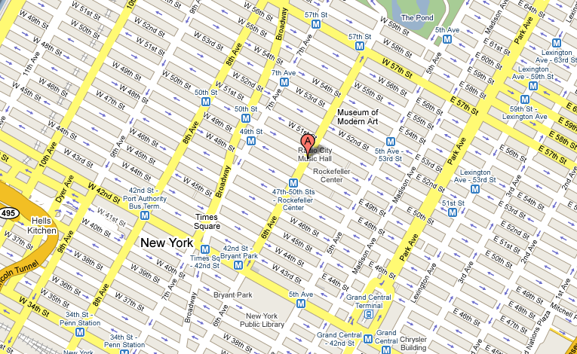
Where did I stay?
I stayed in Newport, Jersey City. James Madison Apartments, just opp. Newport Center. I take the Path (train) from Pavonia to 33rd St.

Who was your manager?
Pavani Koduri. What was her title? She was the PM for the group.

Tell me about the architecture of this application. (This question is also at times phrased as “What was the platform on which you were working”)
This was a typical N tier application with Apache Web server, J2EE compliant app server (I think it was Weblogic) and an Oracle Database.

DEUTSCHE BANK Investment Banking, San Jose, CA October 07 to Present
Senior QA Analyst

DEUTSCHE BANK is a diversified global financial services company, with its main headquarters in Basel & is a global investment management organization. As assets under the company’s management increased, the amount of data to be analyzed and correlated exceeded the portfolio manager’s ability to perform efficiently. The client needed an integrated technology-driven approach to conduct portfolio analysis and to select stocks. The project involved in developing a portfolio management system that provided access to comprehensive information for examining and modeling any aspect of a prospective transaction for immediate execution.

Responsibilities:

- Involved in all design and architecture reviews relating to the Java J2EE backend
- Developed Value Object, Data Access Objects, and Composite Entities using J2EE patterns in java.
- Developed strategies and plans for test automation, and implemented automated test scripts.
- Utilized Remedy Help Desk software to report, track, escalate, and notate resolutions of trouble tickets
- Regularly used BMC Remedy Software for planning, scheduling, implementing and tracking of changes in IT infrastructure in a systematic and controlled way.
- Wrote and performed automated tests in C++, C# and VB scripting
- Developed server side interface components using Java, C++
- Developed Infranet schemas using C++
- Performed White Box and Black Box Testing (Unit and Integration Testing)
- Developed Test Cases to cover overall quality assurance testing.
- Involved in Manual testing using Test Director to develop test cases, test scripts, executing the scripts and logging the defects.
- Performed Manual Testing on different modules of the application.
- Involved in Functionality and Regression testing.
- Extensively used SQL scripts/queries for data verification at the backend.
- Involving in all phases of the lifecycle (Design Development, Validation, QA and UAT).
Performed OQ and PQ Testing of the entire application.
- Work closely with ETL Lead/Project Manager on project deliverables and road blocks
- Work closely with the ETL developers and DBAs during code migration to QA and Production from Development Environment
- Used Clear quest for repository, reporting bugs, tracking bugs and updates on resolved bugs.
- Responsible for first line of defense on all production ETL issues
- Developed strategies and plans for test automation, and implemented automated test scripts.
- Tested Informatica Mappings and worked with Staging area to validate the data with SQL Queries.
- Provided a weekly project report that includes Test Metrics and status reports
- Developed SQL Queries and Procedures to perform database testing using SQL Plus.
- Participated in meetings with developers to discuss enhancements and modifications
- Worked extensively with databases to write complex queries involving aggregates, Joins and Functions.
Environment: QTP 8.0, Test Director 8.0, WinRunner SAP R/3, Dcoumentum 5I, LIMS, Websphere, Informatica 7.1/6.2, Oracle 9i, DB2 UDB, Sybase, MQ Series, DB2, Mainframe, CICS, .net, C#, XML, Performance Center, Quality Center , Business Objects , Webi v6, ERwin 4.0, TOAD, Solaris 8, Windows 2000, Excel, Load Runner.

Tell me something about yourself (QA point of view)?

I am Sravani Dinavahi. I am a Quality Analyst with over 8 years of experience in the testing field. I have worked as a QA team leader supervising a team of about 8 people. Over the years I have been making test plans, test strategies, test scenarios and test cases. I have strong knowledge of SDLC methodologies such as Agile, RUP, and Waterfall model. I also conducted different kind of meetings for the QA team and the entire project teams. Meetings included test case walk troughs, defect review meetings, core team meetings to get estimates,impact on schedule, status and updates. I have strong knowledge of manual testing and automation testing. Over the years I have worked on different automation testing tools such as QTP, Test director, Win runner and load runner. Also worked on various bug management system such as Bugzilla, Clear Quest, Remedy and Quality centre. My expertise lies with leading QA analysts.

Tell me about your role as QA lead?

As a QA lead I was responsible for planning and overseeing all QA activities on a project. Specifically was responsible for all audit, verification (Verification is towards prevention: Code Inspection, Test Plan inspection is all verification ) and validation (Validation is towards detection: Execution of test cases is validation) activities.

When I joined I started attending project team meetings and reviewing project documents supplied by the Project Manager. I was also an integral part of JAD sessions, user interviews so that I can get a very strong handle on the project scope. Then I came up with a schedule which shows all current and upcoming testing efforts and will also shows which user departments are involved in each testing effort (including any overlap of projects being tested).
I distributed project documents to the Test Team and then scheduling test team meetings.

I was also involved in building my Test team by opening requisitions with the HR team. You also involved the PM, BA, business team in hiring of QA analysts. Many times you had to negotiate rates with the preferred vendors of DEUTSCHE BANK (like Satyam Information and TCS).
I was also responsible for setting up the test platform. E.g., figuring out how many floating licenses we need for QTP.
What is your experience with Test Data? Where will we get test data from? We either made it up or imported it from other applications in production. What tools did I use for this? Hmm…Well, just simple SQL. My team wrote SQL scripts to import this data into your QA database. In Production, we were using Oracle 10G Professional edition but in the QA environment, we were using Oracle 10G Express edition (because it is free). While importing production data from production database, I had to make sure that my scripts scramble some sensitive information like SSN, Home address, name, portfolio value, etc.. To scramble, my developers helped me with an algorithm to randomize these numbers.
A QA lead has to fight for budget at times because QA teams sometimes are not treated as well as their development counterparts. QA team is expected to share their QA environment with other QA teams. You fought for independent infrastructure so that your team is getting a solid framework to test on.
Through collaborative efforts with my Team, we defined test requirements (what needs to be tested in detail) and documented these requirements in the Test Requirements Index Section of the QA Test Plan Document.
Then I presented the test requirements to the Project Team in order to gain their approval.
After the approval is received, we developed the detailed test scenarios that meet the test requirements identified in the previous phase. In addition, I was also determining how each test scenario should be tested (i.e. manual or automated) and reach consensus on testing assignments.
- I Created the documents like Manual Test Scenario Documents, QA Test Plan Document and Automated Test Scenarios
- Once the test scenarios were established the test cases were developed with expected results. And we started executing the test cases and recording the results
How was ETL being used in this project?
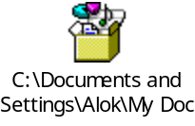

What do you mean by “Work closely with the ETL developers and DBAs during code migration to QA and Production from Development Environment”
I worked with them to make sure reports are still working when code moves from DEV to QA to UAT to Production.

Tell me about some bugs you found:
The two you just mentioned are great. Put them here.

Tell me about a strange bug you found!

Tell me about a time where your team discovered a defect but the development lead did not agree with you and how did you resolve it?
Yes, let me tell you of an incident like this. We had a feature in our DEUTSCHE BANK research application where when an investment banking specialist logs into the application, they see a list of their top 15 clients. While my team (or I) was doing testing on this feature, I came to a realization that this list is not correct. It is my habit to login to the database and run some SQL queries to double check the numbers or data being shown in an application. I noticed that the top 15 clients list in the application did not match up with raw numbers in the database. E.g, the application showed Joe Blow as being the top net worth client with say $13,989,736. When I logged into the back-end database and did my sql queries (mostly selects) and added the outstanding balance of Joe Blow in various asset buckets like stocks, bonds, precious metals, REITs, 401K, I realize that there were some other customers who had higher balance than Joe Blow but were being shown at a lower ranking to the investment banker. So, I raised this bug in Quality Center. However, the bug was rejected by the development lead. Upon further discussions, it became obvious that the way the developers had coded the relative ranking of various customers, they had ignored the 401K component of a customer’s net worth. This aspect of the application was not properly documented in the functional specs of the application. Therefore, my team did the right thing by opening this defect. Turned out that the development team had also done the right thing by not including 401K balance in a person’s net worth calculation (because it was not documented in the FSD). The developers had gotten this information from product managers outside of the regular team meetings. I, as a QA lead, insisted that this feature (of not counting 401K toward net worth) should be properly documented in the FSD in the assumptions section.

What is your experience with Reviewing Technical Design Document?
A BA’s responsibility is not just to create Business Requirements Documents and Functional Spec documents but also to review the Technical Design that is being proposed by the Technical team to implement end user requirements. As such, in almost every project, I had the responsibility to review and sign off (approve) on the Technical Design. I am very well versed with technical design of web based applications. E.g, in my project with DEUTSCHE BANK, I was one of the approvers of the Technicl Design Document. In this Technical Design Document, I noticed the use of N-Tier architecture (Web tier, application server tier and DB tier). The Database being used was Oracle 10G. In reviewing the technical document, I came across the fact that we only had a 2 user license of Oracle 10G. I pointed out that 2 user license is not enough to handle the anticipated usage level of our users (We were anticipating more than 100 investment bankers using this application during peak times). So, I proposed increasing the number of licenses from 2 to 4 during my review.

I also understand the class diagrams and state diagrams that are generally created by the design team. I make sure that the design team (senior developers) has implemented all the attributes in the class diagrams that the business team needs to track. There have been instances where I had to remind the dev team to add a few attributes to the classes since they forgot about it. E.g, for the customer class, the developers had forgotten to include the gender attribute in their class diagram.

I also am able to critique and comment on ER Diagrams. In a nutshell, yes, I am very comfortable in effectively reviewing Technical Design documents.

Tell me about your White box testing experience.

White box testing is all about looking/studying internal layout/logic of the code and then writing test cases to cover things like 1) Branch Testing 2) Coverage Testing 3) Security Testing 4) and Unit Testing.
This portfolio management application was written using Java J2EE. I wrote JUnit scripts to check the functionality of various modules written by developers.

Tell me about your JUnit Experience.
http://junit.sourceforge.net/doc/cookbook/cookbook.htm
http://articles.jbrains.ca/JUnitAStarterGuide.pdf (THIS IS A FANTASTIC JUNIT GUIDE FOR DUMMIES)
JUnit is an open source testing framework for Java.
(Learn about JUnit above)

@Test public void simpleAdd() {
Money m12CHF= new Money(12, "CHF");
Money m14CHF= new Money(14, "CHF");
Money expected= new Money(26, "CHF");
Money result= m12CHF.add(m14CHF);
assertTrue(expected.equals(result));
}

A White Box QA Engineer like Sravanthi, writes this method called simpleAdd() in her Java compiler. So, in a way, you can call simpleAdd() as a test script. The code you are testing is the method add(). You know as a intelligent human being that sum of 12 and 14 is 26. That is why, you created a variable (object) called expected and gave it a value of 26. Then, you let the program under test (add() method) also do the same addition in the line Money result= m12CHF.add(m14CHF); You are storing the output of the program’s logic into a object called result. Then, in the next line assertTrue(expected.equals(result));, you are using JUnit’s method called assertTrue to confirm that expected=actual (result).

Some developer has written the code for method add(). And, you as a White Box QA Engineer, who knows JUnit is testing this method add() through the test case simpleAdd(). assertTrue will return True or false. If it returns true, your test would have passed. Otherwise, it would have failed.

Class called Mom
Object is Madhur of type Mom Class
Mom Madhur = new Mom(“Madhur”);
//Tell Madhur to get Kids ready
Madhur.getKidsReady(); //Madhur is the object who is performing the action (method) of getKidsToReady.

Why is JUnit called test driven development?
This is because as a JUnit QA Engineer, I wrote JUnit tests to test individual methods that developers are coding in almost real time.

In JUnit you pretty much create objects to test the methods of the class that you are testing.
I have used JUnit to test the functionality of modules. E.g., we had a class called Portfolio that had a method to calculate the fees that should be charged a client. This method was called

//If you get this job, this is what you will have to do
- Take up a Java class ASAP!!!! Canvas will pay for it! Not a one semester class. More like a hard core, intense 2 weeks class. Perhaps we will hire an instructor like Pam’s husband (Vivek Biswas).
- Get familiar with concepts of OOP/OOD. Like a dummies book. $50.
- Promise to spend every waking minute studying for this position.

What does Java code look like?
To get used to the syntax, the appearance of a programming language, most beginner programmers learn “Hello World” program. If you were to write JUnit tests for an application you are testing, you will open up the code using an editor. I used Notepad as an editor (and sometimes Eclipse as an Editor). Once you see and understand the classes and methods, you will then write your JUnit scripts to test those classes under test.

A few Java interview questions?
Why is Java so popular?
- Easy to write and understand
- Portable

There are two kinds of programming languages in the world!
OO (Java, C++,Visual Basic 6) and procedural (C, FORTRAN, COBOL, PASCAL)

What is the biggest concept in OOP that procedural programming languages don’t have?
OOP has concepts of classes, methods and objects.

Inheritance:
There might be a high level class called Person
Person class can have 2 subclasses (Man and Woman). Man and Woman have been derived (or inherited) from Person class.

Class called Vehicle
Subclasses of Vehicle would be Car, auto, bus, bicycle.
Car will have further subclasses like sedan, coupe, SUV
The beauty of inheritance is that a subclass automatically “inherits” all the attributes and methods of the parent class.
(Benefit of inheritance is that it becomes really easy to create new classes since you can inherit most of the attributes/methods from parent class and then add more attributes and methods to it).

In Java, can you inherit from multiple classes?
Say Class C needs to inherit from both Class A and Class B? In Java, is this possible? NO. Multiple inheritance is not allowed in Java. It is allowed in C++. Then, what if I do need Class C to have both A and B’s functionality. The answer to this question is in Java, we use the concept of interface.
Class B
Class C
Class A

AGILE: In the morning, you would have SCRUM daily stand-up meetings. I would tell about the progress I have made in writing and executing test cases.

Tell me about your Remedy Experience?
- Utilized Remedy Help Desk software to report, track, escalate, and notate resolutions of trouble tickets. In DEUTSCHE BANK, we used Remedy Help Desk for our investment bankers to capture the issues that our clients had with their portfolios. The primary users of this help desk software were the investment bankers but at times, the issues used to get escalated to Tier II and Tier III support. I was part of Tier II and Tier III support to answer questions that Tier 1 (investment bankers could not answer).
- Regularly used BMC Remedy Software for planning, scheduling, implementing and tracking of changes in IT infrastructure in a systematic and controlled way.
While I was at DEUTSCHE BANK, there was a management decision to migrate our groups’ desktops from Windows XP to Windows Vista. This was a pretty huge change for the entire group. This IT Infrastructure change was documented using BMC Remedy Software. We also had another project where the data center was moving from Roseville, CA to Chandler, AZ. These major IT infrastructure changes were document, tracked and executed through Remedy Software.

How would you go about writing test cases to test the code?
Well, the first thing I do is read the code in an IDE (Integrated Development Environment) like Eclipse. I like to read/edit code in an IDE vs a vanilla editor like notepad because IDEs make the code much more easy to understand and grasp. This is because IDEs mark keywords, functions, packages etc. in different color codes. Once I understand the code, along with the BRDs/FSDs and technical design documents, I write test cases to make sure that all of developers assumptions about operating conditions are violated. Say, I notice that a developer has used an array variable called shoppingCartItems[30];
This means that the developer has assumed that how many items can a shopper buy? Only 30! So, my devilish/destructive mind immediately thinks about writing (and then executing) a test case that would add 30 items and then proceed to add one more. And, I am pretty confident that I will see an array Out Of Bounds Exception (Exception in programming is an error condition)! I don’t even have to wait for the UI to be ready to run this test case. I would write a JUnit test to invoke the addToCart() method of the ShoppingCart class with a particular shopping item. I will do this 30 times. (Put this in a loop statement). And, then, I will confirm that the code gives me an array out of bounds exception.

A black box engineer would have easily missed out on this bug unless it was his lucky day and he happened to add more than 30 products to the cart (unlikely as most black box engineers will perhaps stop after adding 5 or 6 or 7 items to the cart and then just say “Oh Well, It works”);

Variable NameOfPerson: Sravanthi;
Variable AgeOfPerson: 25;

AgeOfPerson and NameOfPerson are a variable of type scalar.
shoppingCart is a variable of type array;

What do you understand by Code Coverage Testing?
As a White Box QA Engineer, one of my duties is to make sure that the entire code is covered by my various test cases. Say, there is a program (code) that is 1000 lines long. It has a lot of If Then Else conditional statements.

Fandango web site code (User has been authenticated).
Start of Code
LOC1
LOC2
IF (ageOfShopper <= 18) THEN
{
Show only moview rated PG or G;
Show kids prices of movie;
}
ELSE IF (ageOfShopper > 18)
{
Show all movies (PG/G/R)
If (ageOfShopper>62) THEN
{
Show Senior Pricing
}
ELSE
{
Show regular adult pricing;
}
}
LOC 60
LOC 70
End of Code;

If you were a white box QA Engineer, you should write test cases with test data:
A shopper who is less than 18 years old
A shopper who is between 19 and 61
And a Shopper who is greater than 62.
Suppose you did not write a test case for a shopper more than 62 years old. What part of code haven’t you tested (The red part)
I used EclEmma as a code coverage testing tool.

I also used in another project, a tool called Cobertura. http://cobertura.sourceforge.net/introduction.html (Read up on it here).

Have you worked on product launches?
I was a part of the team that took the product live from the UAT to the production environment. Usually, these launches happen at god-awful hours since at that time, you have minimal traffic to your application. You might ask why a QA engineer is involved in deployment of product in a production environment. This is because when a product is deployed, then, I as a QA engineer did one last sanity check on the application before opening up the server to the Load balancer which would external customers to come in.

What platforms have you worked on?
I have been lucky to be exposed to various platforms over the last 5 years. Most of the applications that I have worked on have been J2EE applications running on UNIX platform (Sun Solaris, Sun SunOS and Berkely UNIX). Read up on UNIX commands from here.

Tell me of a time when you had to create a use case that had a system as an actor?
Well, let me first tell you some of the use cases I wrote.

- Login to the system
- Logout of the system
- Update customer profile
- Analyze a stock
- Pull out historical report on a customer
- Perform virtual modeling on an investment strategy

One of the features of this application was that at the end of the day, all the information captured by the various investment bankers was collected and verified and then added to the database. In this case, the use case that was invoked was “Record transactions in the SOR”. From the perspective of Record Transactions use case, the application DEUTSCHE BANK Research becomes the actor.

Tell me about your experience with XML?
In this project, many outside entities were interfacing with DEUTSCHE BANK Research. These entities like NYSE, Nasdaq, BSE, LSE (London Stock exchange) used to send data to DEUTSCHE BANK research through XML files on a periodic basis. These XML files have to be processed by our DEUTSCHE BANK Research application and stuffed into our tables for further number crunching. I had to make sure that this information coming from our partners is going to be successfully processed at DEUTSCHE BANK’s end. So, what I did was, I would submit XML files to our DEUTSCHE BANK application with known data (like name of a security, its 52 week high and low, its P/E ratio, etc.) and make sure that this information makes it into our tables (by using SQL). To be able to create this XML, I had to study the schema of the XML so that I know what format to create the XML file in. I used Altova XMLSpy to create this XML file.

Tell me about your Selenium experience:
I was using Selenium testing tool in DEUTSCHE BANK. I was using it to test the web based application we were developing for investment bankers. I automated all the web testing that was needed with this tool. I was using Selenium 2.3 for this. I was using Selenium for doing cross browser testing like with Firefox, Internet Explorer and Safari. I used Selenium’s plug-ins for different web browsers. Also, I used Selenium grid to make our massive test suites run faster by using the parallel processing feature of Selenium grid.

Tell me about your experience with ensuring daily automated integration and regression testing.
Once a build is ready (code is checked out by the build manager using a tool like ANT and compiled and linked and .jar file is created – think of jar file as an executable file), the code is deployed on various servers and the web servers and the application servers are recycled so that the latest build is run. Now, my automation scripts (that I have written using Selenium) wake up (???) and go through the various pages of the application to make sure that the pages are functioning correctly (regression testing is perfomed). If Selenium finds some bugs in the system, then, these errors are recorded in the log files and at the end of the run, notification of these results along with the location of the log files are mailed to QA/Developers for figuring out the reason for the errors.

We used cron jobs to kick off the Selenium tests at a pre-determined time (like 9:20 pm because we knew that the build process will be completed by 9 pm and web and application servers restarted at 9:05 pm).
20 21 * * 1,2,3,4,5 /seleniumScriptToBeRun

